**1.When this issue is created?**

The ticket got issued on 17th April.

2. **When we facing this issue while auto ticket creation time or manual ticket creation time?**

While the auto ticketing is created, we are facing this issue.

3. **Check logs of action, connector, rule engine.**



**Payload we tried:**

{  
    "sid": "scheduler_bWFuaXNoLjEucmFuamFuLWV4dHNhMUBvbmVjbGFyaW9zLmNvbQ__search__RMD58e65d58665a9e191_at_1605252300_29409",  
    "search_name": "webhook Testing 3",  
    "app": "search",  
    "owner": "",  
    "results_link": "",  
    "result": {  
        "alert_types": "Transactional",  
        "description": "Processing Completed to get Credit Info from QAD-CHINA.",  
        "source": "Splunk",  
        "actual_timestamp": "2020-11-13 07:16:59.900",  
        "alert_state": "ERROR",  
        "cmdb_ci": "sa-sfdc-sa0014-v1",  
        "Flow_Number": "",  
        "error_type": "CONNECTIVITY",  
        "tracing_id": ""  
    }  
}

**Alerts and ticket created without getting appended:**

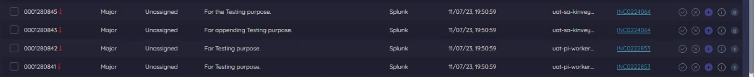

**The mandatory caller and configuration fields are not getting populated:**

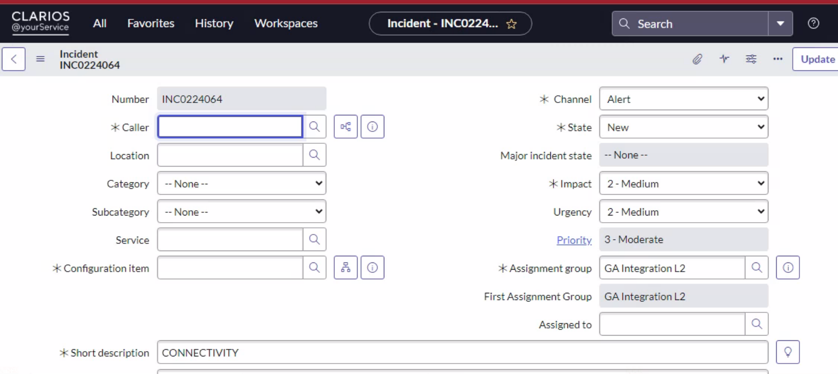

**Inspect Details:**

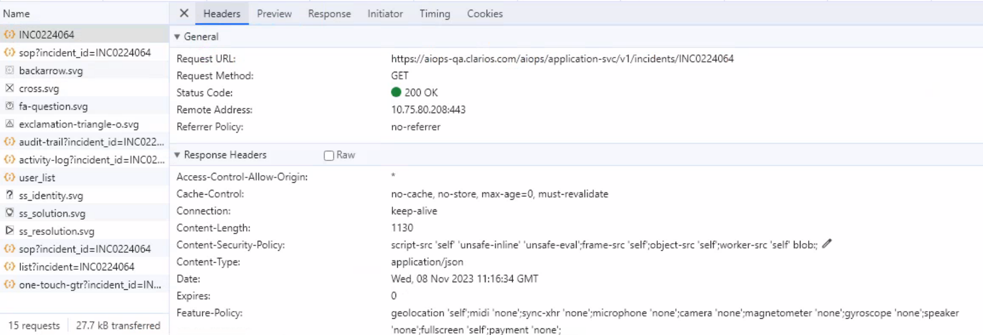

**Reference for where all mandatory fields are populated**:



